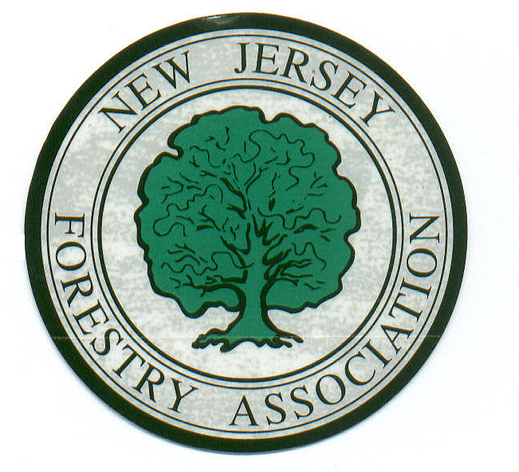

New Jersey Forestry Association

PO Box 367

Flemington, NJ 08822
908-832-2400 Phone/Fax
________ www.NJForestry.org

December 16, 2014

Public Comments Processing
Attn: FWS-R5-ES-2011-0024
Division of Policy and Directives Management
U.S. Fish and Wildlife Service
4401 N. Fairfax Drive, MS 2042-PDM
Arlington, VA 22203

RE: Final Determination on the Proposed Endangered Status for the Northern Long-Eared Bat, 78 Fed. Reg. 61046 (October 2, 2013)

To whom it may concern:

On behalf of the New Jersey Forestry Association, we appreciate the opportunity to submit comments pertaining to a Federal plan to list the Northern Long-Eared Bat (NLEB) as endangered. Certainly, this species deserves protection; however, we do not think that it should be listed as “endangered” but rather as “threatened.”

The New Jersey Forestry Association represents thousands of private landowners who are engaged in sustainable forestry management. If the NLEB is listed as endangered by the US Fish & Wildlife Service, the proposal would trigger a blanket prohibition of restrictions, causing hardships for millions of forest landowners across the country. Such restrictions would result in the following:

- Restrictions on warm season timber harvesting from April to October;
- Limiting activities within a five-mile radius of bat hibernacula;
- In known or potential summer habitat, restrictions would be in force within 1.5 mile radius of any known roost tree or 3 miles from any location where NLEB has been captured or acoustically detected;
- As an example from interim guidance as a conservation measure for detecting the bat: “retain and avoid impacting potential roost trees, which includes live or dead trees and snags equal to or greater than 3 inches in diameter at breast height that have exfoliating bark, cracks, crevices, or cavities”; and
- Any activity that involves removing summer roosting trees could impact the species and result in an unlawful take. However, tree clearing restrictions that may be imposed would likely have a minimal impact on preserving the species.

Page 2
Northern Long-Eared Bat

We urge the USFWS to designate the NLEB as “threatened” and also to attach the 4(d) rule, which would provide some flexibility in the performance of sustainable forest management as set forth in the Best Management Practices being used by certified foresters. We are also pleased to support the comments submitted by the Society of American Foresters (SAF).

Thank you for your consideration.

Sincerely,

Richard M. Conley
President
New Jersey Forestry Association

The New Jersey Forestry Association was founded in 1975 and incorporated in 1983 to promote forestry and forest management on public and privately owned woodlands throughout New Jersey. There is a need for an organization which can act as a spokesperson and advocate for woodland owners, conservationists and others interested in maintaining our forests. We welcome all people who share these values and concerns to join our Association and participate in our varied activities and programs.

