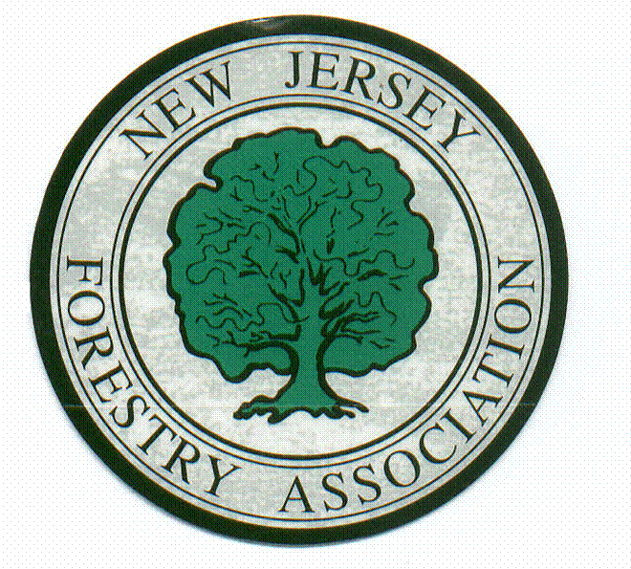

New Jersey Forestry Association
48th Annual Meeting
Registration

Saturday, March 18th, 2023
Cook Campus Center, Rutgers University, 59 Biel Road, New Brunswick, NJ 08901

Registration Fees:
Discounted Member Rate: $75/person
Non-Member: $95/person*

*Save $20 – join the NJFA today. Add membership to your order today.

To assist our staff, all attendees are asked to register in advance (by 3/10/23).
Complete and Return this Form or Register online by scanning this code:

Payment may be made at the door, but you must be pre-registered.
For directions, please contact the NJFA office.

Name: _____________________________________ # Attending: __________________

Telephone # __________________ E-mail Address: _____________________________

Address: ________________________________________________________________

_________________________________________________________________________

Registration Fee: $________ Discounted Member Rate ($75/person) OR
$________ Non-Member Rate ($95/person)

$________ 2023 Membership ($55)
Total
Amount Enclosed: $________
(Make checks payable to New Jersey Forestry Association)

Please mail (before 3/10/23) to:
NJFA Annual Meeting, PO Box 367, Flemington, NJ 08822
If registration will not be received by 3/10, please call to reserve your seat

This program has applied for NJ Taxation, Continuing Education Credits, LTE/LTCO CEUs, Community Forestry Credits & SAF CFE Credits

